Performance Data

Quarter 1 2020-21



# Key Information

This report forms part of the appendices of the “Performance Monitoring Report” update to the Scrutiny Budget and Performance Panel, and Cabinet on the progress at the end of Quarter 1 (April - June 2020) of the Corporate Plan 2019-23. This report reflects the changes to the Corporate Plan as approved September 2019 and outlines the performance broken down by four sections (Outcomes):

* Excellence, Investment and Financial Sustainability;
* Health, Wellbeing and Safety;
* Place, Homes and Environment;
* Our People and Communities

Within each section is a summary of all activities and their performance status at the end of Quarter 1.

**Performance Key**

|  |  |
| --- | --- |
| **Symbol** | **Determination** |
|  | If we are doing well then it is **Exceeding.** Where a project or task has been achieved ahead of the due date set or a measure has achieved beyond its target. |
|  | It is **On-track** where a project or task will be delivered on the due date set or a measure is within its agreed targets |
|  | It is **Off-track** where a project or task has not met its required due dates, or a measure has not met its targets |
| Picture1 | **Completed/Closed**: project has been completed, meeting milestones and actions. |

The Key Performance Indicators (KPI) for Quarter 1 display progress against the outcomes of the Corporate Plan on Health, Excellence, Communities and Environment.

|  |  |  |
| --- | --- | --- |
| **Trend** | **Determination** | **Note** |
| ⮉ | This shows that the reported figure has increased since it was last reported. | *The trend key shows how a measure is performing against its previous reported figure. The colour of the item details whether the direction is negative, positive. These are the same colours as used on the performance key for succeeding and off track.* |
| ⮋ | This shows that the reported figure has decreased since it was last reported |
| ⮊ | This shows that a measure has stayed the same and not moved |

|  |
| --- |
| Excellence, Investment & Financial Sustainability **Excellent services and a strong financial position that enables us to invest in the right way** |

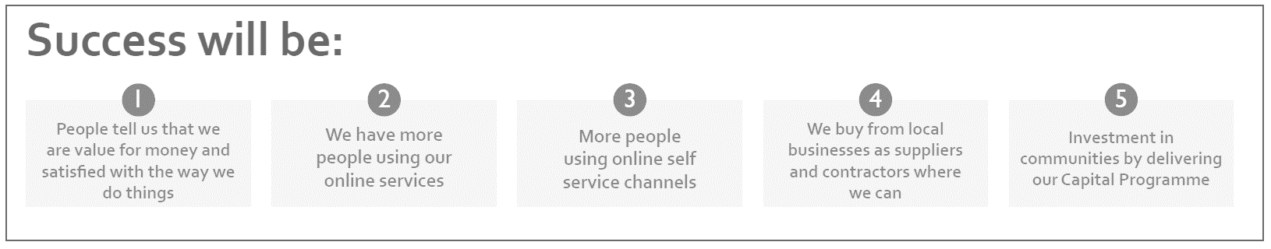

## Our Key Performance Indicators:

|  |  |  |  |  |  |
| --- | --- | --- | --- | --- | --- |
| **Key Performance Indicator** | **Baseline / Target** | **Comparable Period** | **Quarter 1**  **2020/21** | **Status** | **Trend** |
| % of self-service channels access vs phone/face to face | 40%  (2020/21) | 22%  (Q4: 2019/20) | 37% |  | ⮉ |
| Increase in income from commercially operated assets: Business and Conference centre | 10% Increase | 20%  (Q1: 2019/20) | 0% |  | ⮋ |
| Increase in meeting hours in the Business and Conference Suite | 10% Increase | 4%  (Q1: 2019/20) | 0% |  | ⮋ |

|  |  |  |  |  |  |
| --- | --- | --- | --- | --- | --- |
| **Service Level Indicators** | **Baseline / Target** | **Comparable Period** | **Quarter 1**  **2020/21** | **Status** | **Trend** |
| % of telephone calls answered within 90 seconds | 40%  (2020/21) | 61%  (Q4: 2019/20) | 73% |  | ⮉ |
| % of calls abandoned before being answered in a quarter | 18%  (2020/21) | 11%  (Q4: 2019/20) | 9% |  | ⮋ |
| Complaints as a % of total contacts to our customer contact centre (Gateway) | 2%  (2020/21) | 0%  (Q4: 2019/20) | 0% |  | ⮊ |
| Complaints against the Council Upheld | No Target | 27  (Q4: 2019/20) | 0 |  | ⮋ |
| Average days to process a new Housing Benefit claim | 19 days | 16.6 days  (Q4:2019/20) | 13 days |  | ⮉ |

## Quarter 1 Project Status

|  |  |  |
| --- | --- | --- |
|  | **2019-20** | **2020-21** |
| **What we will do** | **Quarter 4**  **Jan -Mar** | **Quarter 1**  **Apr – Jun** |
| EIFS01 – Customer Experience |  |  |
| EIFS02 – Shared Services |  |  |
| EIFS03 – Conference and Business Centre |  |  |
| EIFS04 – Leisure Management Options |  |  |
| EIFS05 – Implement first year of the Councils Digital Strategy |  |  |
| EIFS06 -Review of the Council’s Surplus Sites |  |  |

|  |
| --- |
| Health, Wellbeing and Safety **Residents are happy, healthy and safe, active and independent** |

## Our Key Performance Indicators

There are no performance measures to report under this corporate priority this quarter.

## Quarter 1 Project Status

|  | **2019-20** | **2020-21** |
| --- | --- | --- |
| **What we will do** | **Quarter 4**  **Jan -Mar** | **Quarter 1**  **Apr – Jun** |
| HWS01 - South Ribble Dementia Action Alliance |  |  |
| HWS02 - Open Space Sports and Recreation |  |  |
| HWS03 - Green Links |  |  |
| HWS04 -Improving our Existing Leisure Centres |  |  |
| HWS05 - Activities and Events for People of All Ages |  | **Closed** |
| HWS06 - Interact with the Council Digitally |  |  |
| HWS07 - Community Safety to tackle Crime and Disorder |  |  |
| HWS08 - South Ribble Partnership |  |  |
| HWS09 - MH2K |  | **Closed** |
| HWS10 - Reduce the Number of Homeless |  |  |
| HWS11 - Mind the Gap |  |  |
| HWS12 - First Class Advice Services |  |  |

|  |
| --- |
| Our People & Communities **Strong and active communities where people are engaged and have a voice.** |

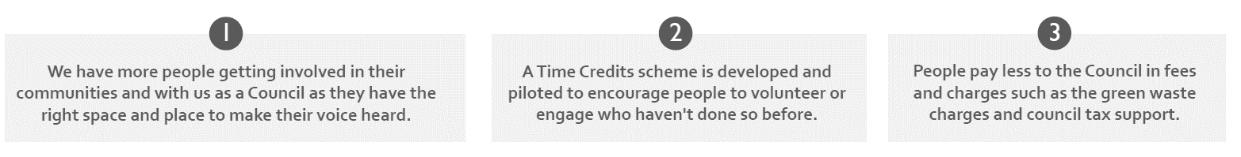

## Our Key Performance Indicators

|  |  |  |  |  |  |
| --- | --- | --- | --- | --- | --- |
| **Key Performance Indicator** | **Baseline / Target** | **Comparable period** | **Quarter 1**  **2020/21** | **Status** | **Trend** |
| Number of people removed from the minimum £3.50 per week contribution (Council Tax Support Scheme) | 1900  (2020/21) | - | 2382 |  | - |

## Quarter 1 Project Status

|  |  |  |  |
| --- | --- | --- | --- |
|  | **2019-20** | | **2020-21** |
| **What we will do** | **Quarter 4**  **Jan -Mar** | **Quarter 1**  **Apr – Jun** | |
| OPC01 - Review Community Involvement approach |  |  | |
| OPC02 - My Neighbourhood Plans. |  |  | |
| OPC03 - Revised Council Tax Support Scheme for 2020-21 |  |  | |
| OPC04 - Community Bank/Credit Union | Not Started (July 2020) |  | |
| OPC05 - Member Induction Programme and Member Development Programme |  |  | |
| OPC06 - Develop a Youth Council |  |  | |
| OPC07 - Gain Accreditation as a Living wage Employer |  |  | |
| OPC08 - Council's Approach to Volunteering and Active Citizens |  |  | |
| OPC09 - Apprentice Factory Phase 2 |  |  | |

|  |
| --- |
| Place, Homes & Environment **Our green spaces are valued, and development is well managed.** |

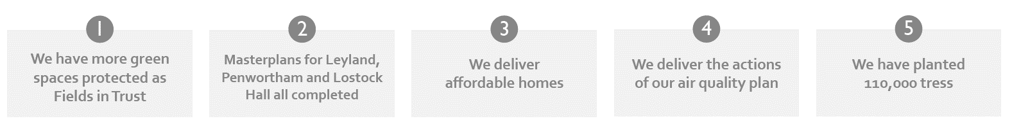

## Our Key Performance Indicators

|  |  |  |  |  |  |
| --- | --- | --- | --- | --- | --- |
| **Key Performance Indicator** | **Baseline / Target** | **Comparable Period** | **Quarter 1**  **2020/21** | **Status** | **Trend** |
| Number of new residential homes (per annum). | 328 (2019/20) | 417  (2018/19) | 357  (2019/20) |  | ⮋ |

## 

## Quarter 1 Project Status

|  | **2019-20** | **2020-21** |
| --- | --- | --- |
| **What we will do** | **Quarter 4**  **Jan -Mar** | **Quarter 1**  **Apr – Jun** |
| PHE01 - Develop a strategy and action plan to halt overall loss of England’s biodiversity |  | **Pause & Review** |
| PHE02 - Plant 110,000 trees in South Ribble |  |  |
| PHE03 - Carbon Neutral by 2030 |  |  |
| PHE04 - Single Use plastics |  |  |
| PHE05 - Borough's Air Quality Action Plan |  |  |
| PHE06 - Bring Worden Hall back in to use |  |  |
| PHE07 - Invest and develop our parks and play areas |  |  |
| PHE08 - Develop a Programme for festivals and events, with at least 1 music festival |  | **Pause & Review** |
| PHE09 - Ensure our parks and existing cherished local open spaces can be protected |  | **Pause & Review** |
| PHE10 - Manage the rate of delivery of new homes and commercial floor space |  |  |
| PHE11 - Scope and prepare masterplans for Leyland, Bamber Bridge and Penwortham town centres |  |  |
| PHE12 - Implement Phase 2 of the Employment and Skills Plan (Cuerden) |  | **Pause & Review** |
|  | **2019-20** | **2020-21** |
| **What we will do** | **Quarter 4**  **Jan -Mar** | **Quarter 1**  **Apr – Jun** |
| PHE13 - Prepare strategy for supporting new and small businesses |  |  |
| PHE14 - Review the projects listed in the City Deal Business and Delivery Plan 2017- 20 |  | **Pause & Review** |
| PHE15 - Review the Local Plan |  |  |
| PHE16 - River Ribble Green Link |  |  |
| PHE17 - Prepare and implement a Central Lancashire Economic Strategy |  | **Pause & Review** |
| PHE18 - Provide quality homes that people can afford to live in |  |  |
| PHE19 - Private Sector Stock Condition Survey |  |  |